PRESS RELEASE

COMMUNICATIONS AND MEDIA TEAM OF THE 2023 ASEAN SUMMIT

No. 13/SP/TKM-ASEAN2023/ENG/4/2023

Indonesia's ASEAN Chairmanship at a Historic Milestone, Academic Says

Depok, 30 April 2023 - Indonesia's chairmanship of the Association of Southeast Asian Nations (ASEAN) becomes a significant historic milestone, said an academic from the University of Indonesia (UI) on Sunday (30/4/2023).

"At least, there are three points that make Indonesia's ASEAN Chairmanship important," said Shofwan Al Banna Choiruzzad, Executive Secretary for the ASEAN Study Center of Social and Political Sciences Faculty at University of Indonesia

Firstly, the world, including the Southeast Asian region, is currently still in a post-pandemic recovery situation and a global economic slowdown, he said.

Southeast Asia as one of the world's few growth points has become an important region to help the global recovery.

Secondly, there is an increasing geopolitical tension, especially in the Indo-Pacific region in which the ASEAN countries are located.

Thirdly, said Shofwan, in the midst of these two big challenges, ASEAN is facing immensely complex challenges from within the region, such as the Myanmar crisis.

Therefore, the 2023 ASEAN Summit must be able to translate the ASEAN Outlook on Indo-Pacific. "Including concrete cooperation which has an impact on the centrality of ASEAN in the Indo-Pacific," he said.

The 42nd ASEAN Summit 2023 which will be held in Labuan Bajo, East Nusa Tenggara (NTT), on 9—11 May has eight meeting agendas.

According to Foreign Minister Retno Marsudi, eight meetings in plenary and retreat formats are scheduled to be held at the 42nd ASEAN Summit, seven of which will be chaired by President Joko “Jokowi” Widodo.

The Summit series of event will begin on 8 May with a Senior Official Meeting and will continue with a foreign ministerers’ meeting on 9 May. Meanwhile, the summit will be held on 10—11 May. (Feru Lantara Antara/TR/Elvira)

***

For more information, please contact:

Director General of Public Information and Communications of the Ministry of Communications and Informatics - Usman Kansong (0816785320)

Get more information at http://asean2023.id and https://infopublik.id

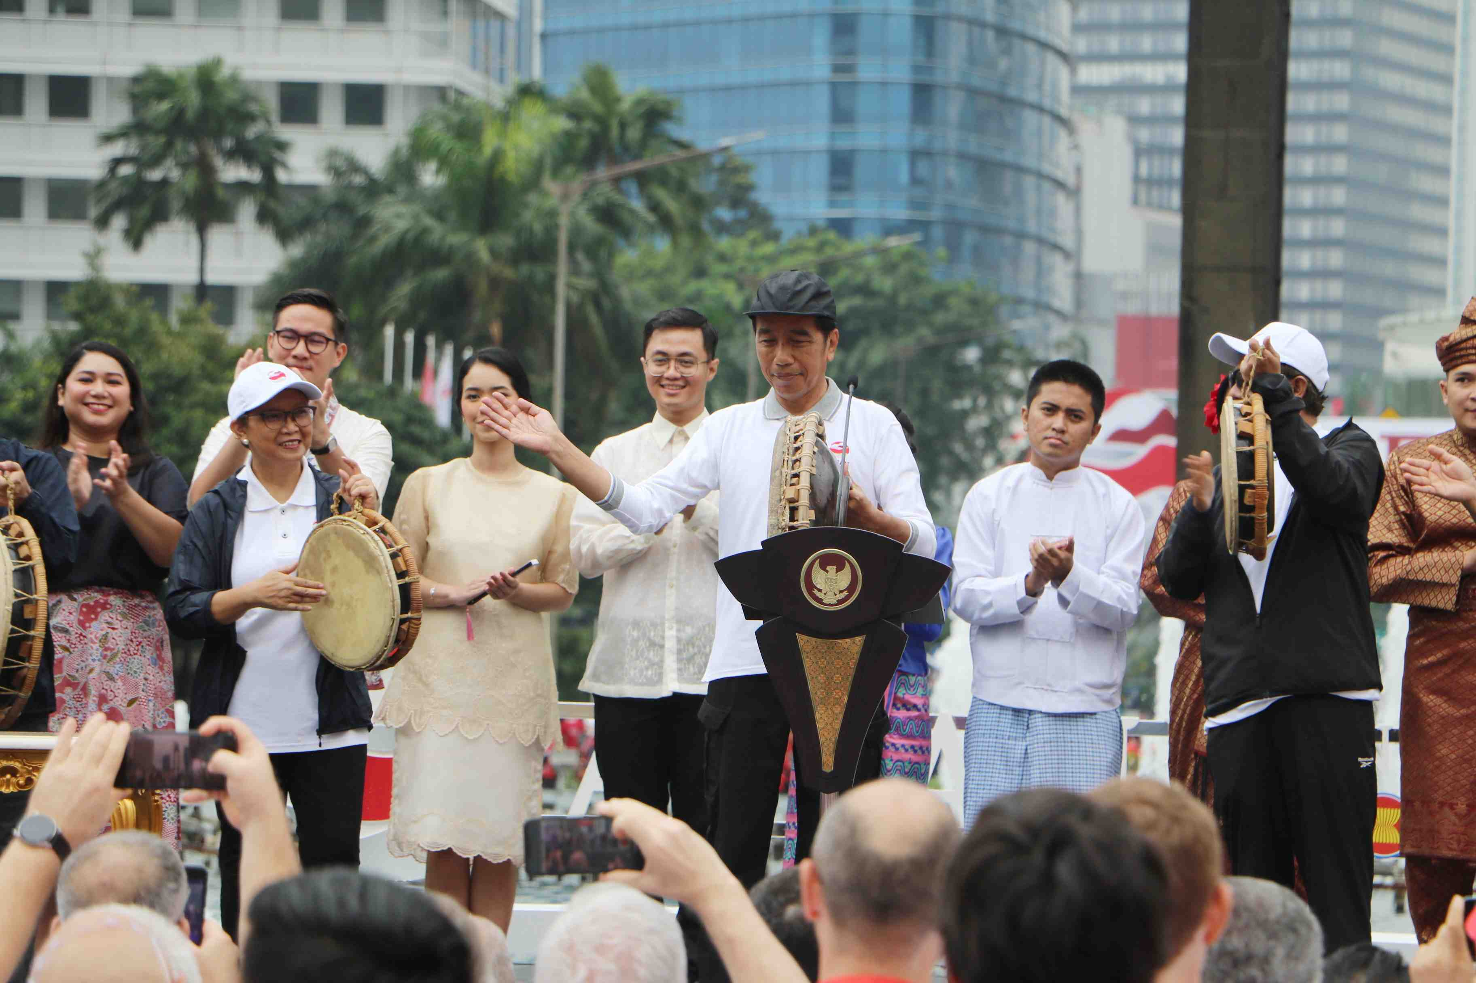

President Jokowi (center) hits a tambourine to kick off Indonesia’s ASEAN Chairmanship 2023 at the HI Roundabout, Jakarta, Sunday (29/1/2023). President Joko “Jokowi” Widodo is optimistic that under Indonesia's leadership, ASEAN will continue to grow and make a major contribution to the region and the world. The kickoff marks the start of Indonesia’s Chairmanship in ASEAN 2023. Infopublik/Amiriyandi.

